

**Hillside Rod & Gun Club**

**3rd Annual Predator Hunt**

### **$40 registration fee per team – Must be pre registered (Deadline November 6th) you do not need to be a member to join – open to the public**

* $10 Optional pot for most animals
* Scoring as follows: Heaviest Coyote, Heaviest Red Fox, Heaviest Gray Fox, Heaviest Raccoon, Longest Tail Opossum
* SIDE POT: Prize for every Rabbit brought in, rabbit must be left at club as a donation for game dinner
* Payout amounts for heaviest will depend on number of teams to register, prize for longest tail opossum
* each team member will be registered for a chance to win a FOXPRO X24 Game Call
* Prizes must be claimed in person within 30 days or a new winner will be drawn
* No min – 3 person team max, more than one team can hunt together (only one team can score animal)
* each team member must show proof of PA hunting license all teams must abide by the PA state game commissions rules & regulations; all animals must be harvested in pa during the dates & times of this hunt. Any violation of the Pennsylvania Game Laws & rules of this hunt will result in that person or team being disqualified from the hunt & banned from any future contests
* NO ANIMALS will be accepted if proven to be trapped or road kill
* Each team will be required to submit a picture via text with the team # given displayed on the animal at the time of kill (Number MUST be in the physical image and NOT written on after photo is taken)
* All Animals Must be in the Parking lot for weigh in by 12PM Sunday November 10th – any arriving late will not be eligible
* At least one member from each team must be present on November 10th at 12PM to win
* you must have in your possession at weigh in: photo ID & PA hunting license, We WILL be checking licenses
* official Weigh ins will be held at

Hillside Rod & Gun Club – 625 Gulick St, Blossburg PA 16912

* + - Thursday – November 7th 5:00 PM – 7:00PM
    - Friday – November 8th 5:00 PM – 7:00 PM
    - Saturday - November 9th 2:00PM – 6:00PM
    - Sunday – November 10th 10:00AM – 12:00PM

Questions Contact Cassie 570-404-2898

Text picture of Animal & team # at time of kill to Cassie

*you will receive your team number the night prior to the hunt

**Hillside Rod & Gun Club**

**3rd Annual Predator Hunt Registration**

**November 7th 12:01 AM – November 10th 12:00 PM**

Team Name:______________________________________________

* Hunters Name _______________________________________
* Email Address_______________________________________
* Hunters Name _______________________________________
* Email Address_______________________________________
* Hunters Name _______________________________________
* Email Address_______________________________________
* contact phone # to receive team # night prior of hunt

$10 Optional Most Animal Pot _____

Please submit all registrations & $40 (or $50 with optional pot) entry fee to

Hillside Rod & Gun Club during Business hours by November 6th in Person,

by Mail PO Box 71, Blossburg PA 16912, or Message for virtual payment options

Questions Contact Cassie 570-404-2898

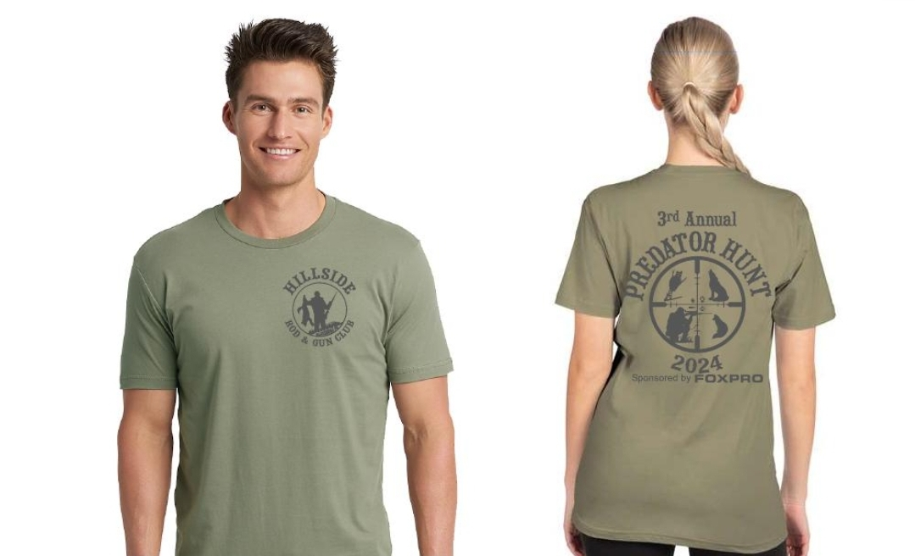Shirts available for purchase at the club during hunt